Account Determination (Fixed Assets Group GL Account Section in FTIS FAv13)
- Go to Administration > Setup > Financials > Fixed Assets > Account Determination.
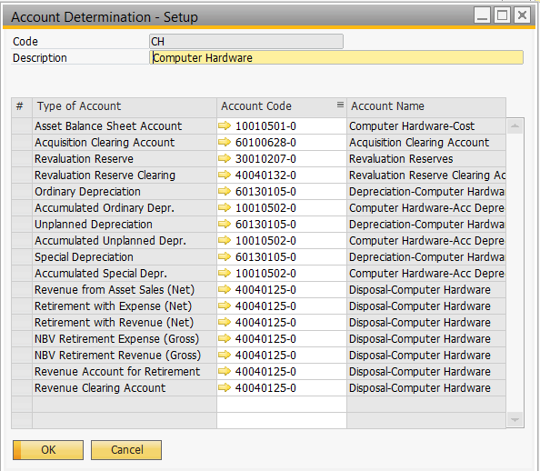
- What I know.
Type of Account | Used in | Debit | Credit
Asset Balance Sheet Account | Capitalizations | Asset Balance Sheet Account | Acquisition Clearing Account
Acquisition Clearing Account | Capitalizations | Asset Balance Sheet Account | Acquisition Clearing Account
 | AP Invoice | Acquisition Clearing Account | Trade Creditors
Revaluation Reserves | Asset Revaluation (Value Increased) | Asset Balance Sheet Account | Revaluation Reserves
 | Asset Revaluation (Value Decreased) | -Revaluation Reserves  -Depreciation Account | Asset Balance Sheet Account  -Accumulated Depreciation Account
All Depreciation Account | Depreciation Run / Manual Depreciation/ Asset Revaluation (Value Decreased) | Depreciation Account | Accumulated Depreciation Account(Indirect Posting)  Asset Balance Sheet Account(Direct Posting)

